ALT-Text=

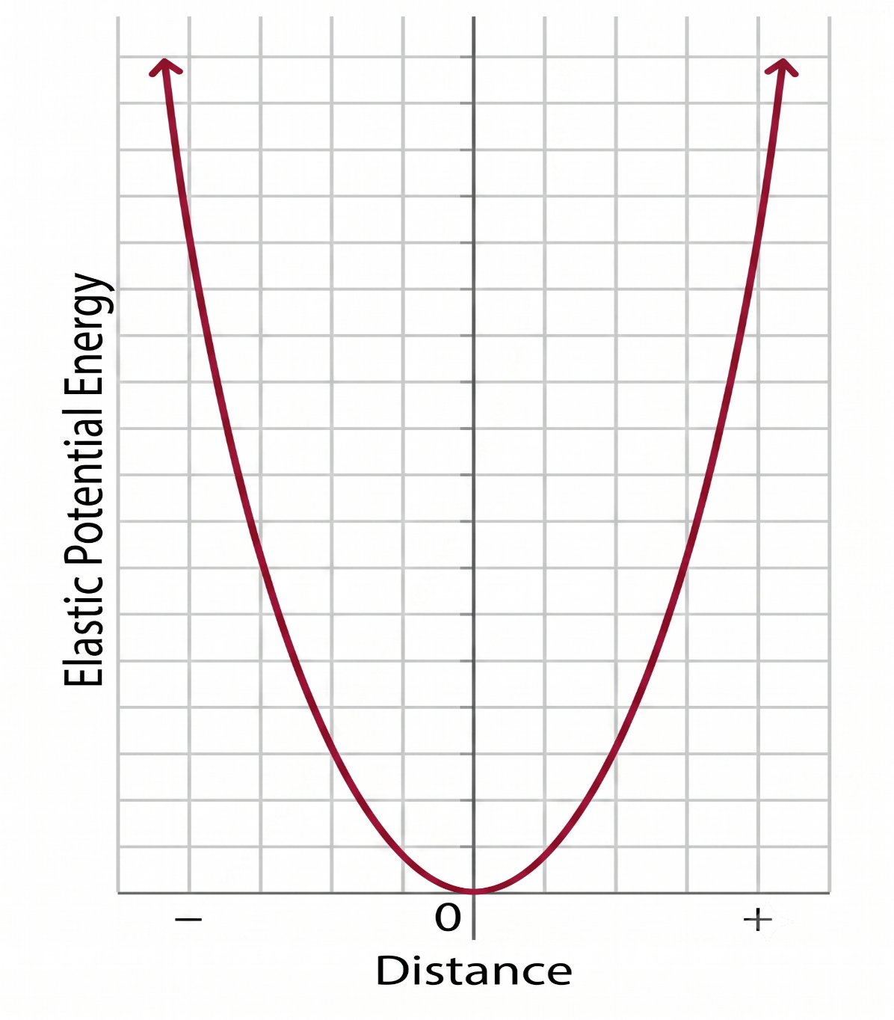

ALT-Text: A graph of elastic potential energy versus distance is shown. On a white background with a light grey grid, a dark red parabolic curve forms a symmetrical "U" shape, opening upwards. The curve starts at the origin (zero distance, zero energy) and rises in both the positive and negative distance directions, with arrows at both top ends indicating it continues upwards. The vertical axis is labeled vertically to the left as "Elastic Potential Energy." The horizontal axis is labeled below as "Distance," with a central "0", a minus sign ("-") to the left, and a plus sign ("+") to the right, showing distance is displacement from a rest position. The graph illustrates that potential energy increases with distance in either direction from equilibrium.

